Yifeng Liao, Talal Al-Otaibi, Carlos Salazar

ME348F Advanced Mechatronics 2

Lab 1 report

September 12, 2022

Lab Exercise 1:

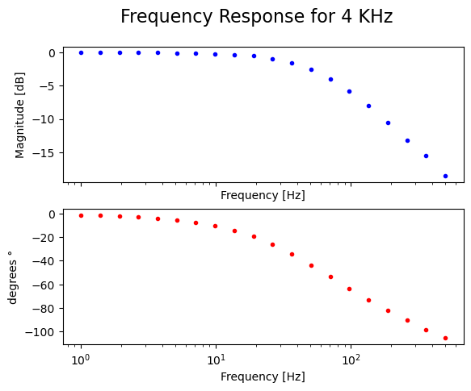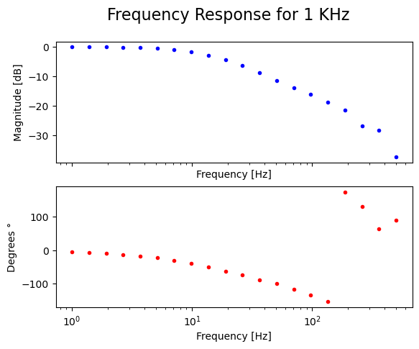
Figure 1: Low pass filter-Bode plot for 4KHz and 1KHz

Discussion of Sampling Rate Effect for the RC circuit
Comparing the frequency responses of the RC circuit at sampling frequencies of 4KHz and 1KHz (for 20 data points), we notice that both frequency response plots are similar except the region near 500Hz. For the 4 KHz plot, the frequency response closely matches the predicted frequency response such that the phase margin final point is near -90 degrees. There appears to be no ‘random’ sharp spikes in data. As for 1 KHz, the magnitude vs frequency plot begins to deviate from the predicted form but still shows a downward trend. However, the spike in data is far more prominent for the phase-frequency plot.

To explain this, it is important to consider the Nyqyuist-Shannon sampling theorem, which states that the minimum sufficient sampling rate needed to correctly sample a signal is twice the natural frequency. In the case of 1 KHz sampling rate, the maximum frequency at which a signal’s characteristics (i.e phase and magnitude) can be properly captured is 500 Hz, and 2000 Hz for a sampling frequency of 4KHz. When plotting the data from the range of 1-500Hz, sampling at 4KHz is enough to sufficiently capture the contents of any signal which explains the smoothness of the data as seen in figure 1. However, this is not the case for the 1KHz dataset. At frequencies of 500 Hz, realistically, any collected data is prone to being erroneous (both in magnitude and phase). However, this error is more prominent in terms of phase because of the proportion of sampling time delay with respect to signal time period; this causes the captured signal phase to be delayed in comparison to the actual phase thus causing the phase readings to be more negative. Moreover,, this delay in phase triggered phase wrapping in LabView which further worsens the reliability of the reading. Overall, a time delay due to sampling digital signals can be modeled as a transfer function such that it is of magnitude equal to one, yet adds phase delay to phase-frequency plots.

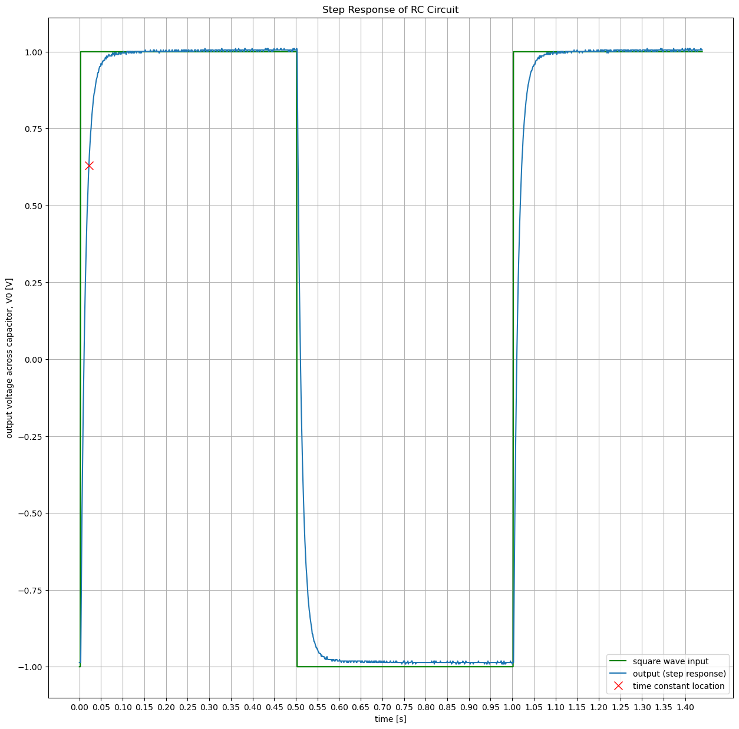
Figure 2: Low pass filter-Step response

Figure 2 shows the response of the RC circuit. In it we can experimentally obtain the value of time constant tau. experimentally it is 0.011[s] which is the value obtained in the preLab (R*C=0.01[s])

Lab Exercise 2:
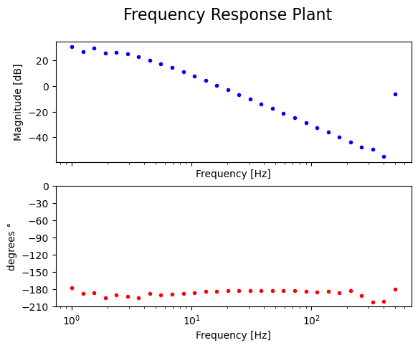
Figure 3: Double integrator Bode plot of the Plant

The frequency response of the plant is as expected compared to the graph obtained in the prelab. The magnitude has a slope of -40 dB/dec and a constant phase of -180º
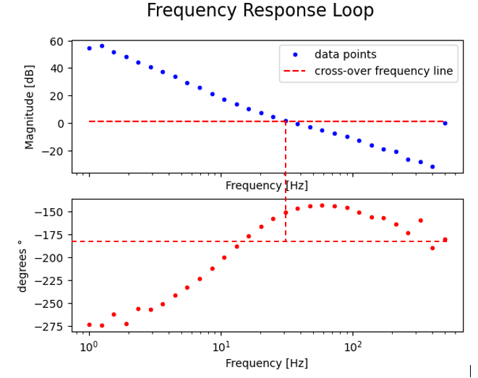

Figure 4: Double integrator Bode plot of the Loop

According to Figure 4, the experimental crossover frequency is about 30Hz (188 rad/s). If we compare it with the design frequency 200 rad/s, it is a little smaller. This in turn modifies the phase margin of the system. The experimentally obtained phase margin is about 30°. The phase margin obtained through the design of the controller was 31.5°, which is also a little smaller but still meets the design requirements. The differences between the experimental data and the design/simulation can be due to a delay generated by the sampling rate

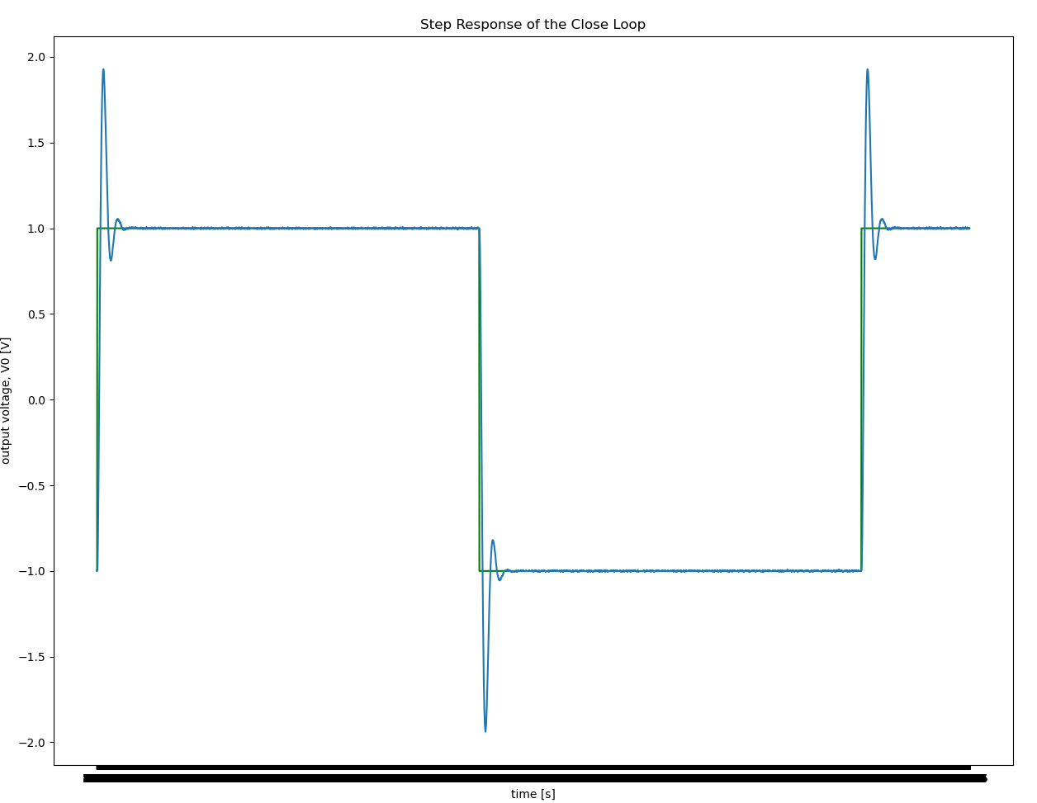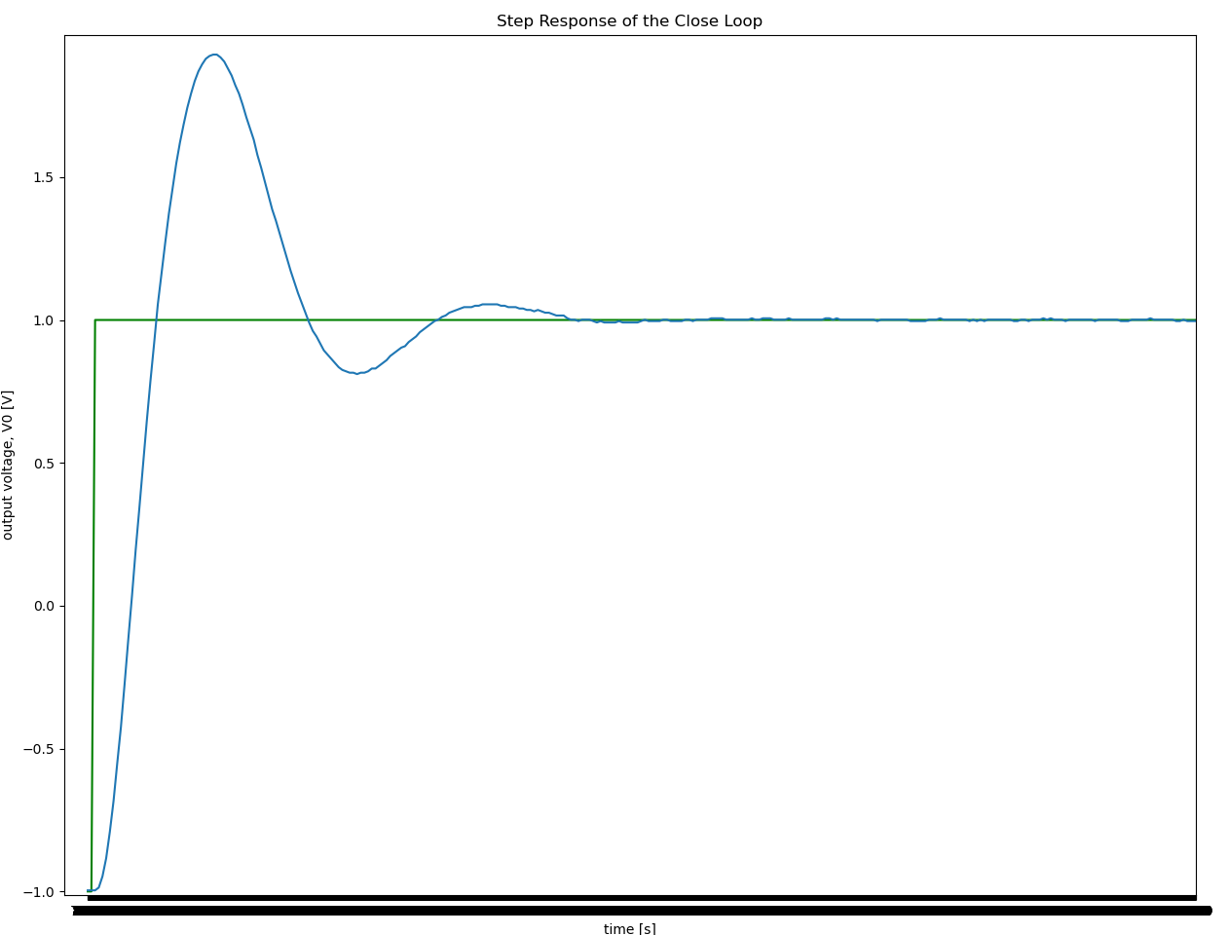
Figure 5: Experimental step response of the double integrator circuit

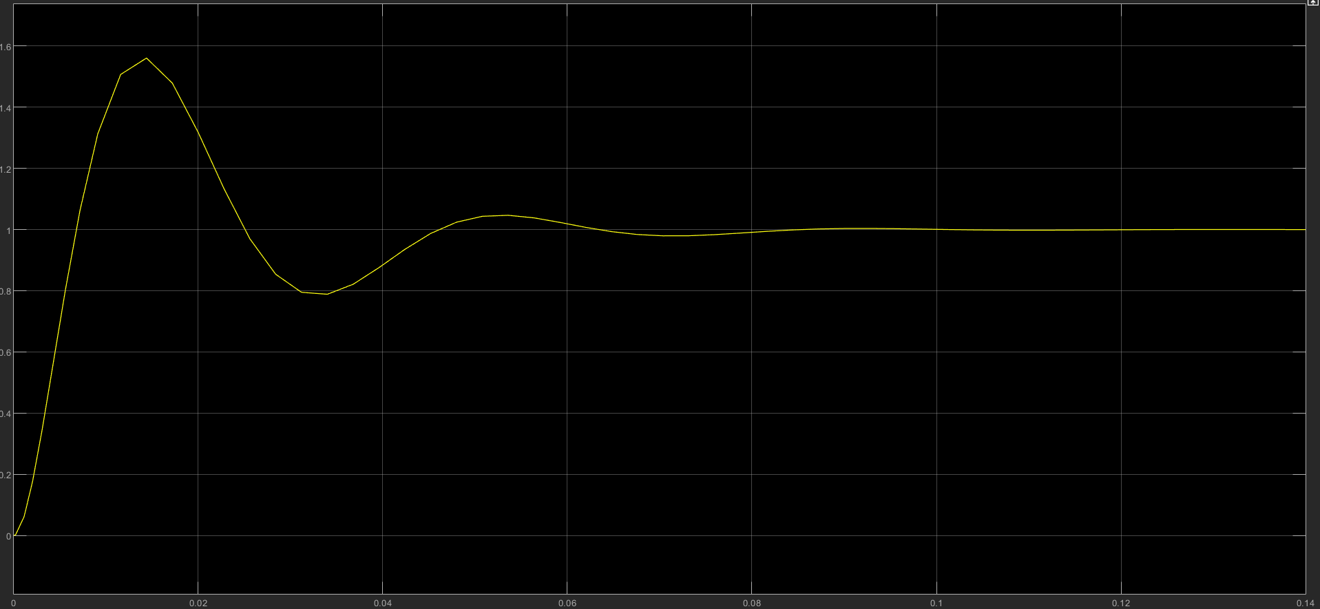
Figure 6: Predicted step response of the double integrator circuit from Matlab

When comparing the experimental step response and the theoretical step response of the double integrator circuit, we find that the experimental one has higher overshoot than the theoretical one. This is mainly caused by the sampling delay of the DSA loop such that the phase margin reduces. Since phase margin is proportional to the damping ratio of the system, the damping ratio gets lowered and makes overshoot higher.

In addition, visually, due to the saturation voltage range of the myRIO, if the step input is higher than the allowed voltage range (-10V to 10V) of the myRIO, the overshoot would look smaller than it actually is.

